May 30, 2017
When is an Architectural Change Request required?
Sagamore Rules and Regulations state:
- Homeowners must submit a written application, using the Architectural Change Request (ACR) form to propose any alterations to the exterior of the home. The ACR form is available from the current Sagamore Community Association’s Management Agent upon request and online at www.sagamorehoa.com. Changes include but are not limited to decks, lighting, painting, adding any exterior components, and landscaping. Along with the ACR, the plans and specifications showing the nature, kind, shape, height, materials, floor plans, color schemes, and locations must be submitted to the Board of Directors via the management company for approval.
- No homeowner or resident may alter any exterior portion of a home without prior written approval of the Board of Directors and, if necessary, the appropriate Township and other government approvals. Homeowners are responsible for obtaining required permits and must adhere to applicable East Bradford Township codes/ordinances. Homeowners are responsible for ensuring contractors are properly licensed and insured.
- If the Board of Directors fails to give written approval within thirty (30) days from the date the ACR is received by the Managing Agent, approval will be denied unless further communication is received. Any approved alteration or addition is subject to a final inspection by the Managing Agent and/or the Board of Directors.
Note:
Section B 19)
a. Deck modifications, extensions, replacements, and stair installations must be approved by the Board of Directors prior to construction. An ACR must be submitted with a copy of the construction plan and a materials list.
b. The name of the constructor and proof of constructor’s insurance must also be provided prior to construction.

Exceptions to submitting an ACR:
- Section B. 12) Light fixtures in the front of the house must be of polished or antique brass. The following represent approved outdoor light fixtures for the front or back of the house and do not require the submittal of an ACR:

The following may also be installed at the rear of the house:

- Deck stain colors are already approved and stain colors and manufacturers are listed in Rules and Regulations:
Section B. 19) f. Wood decks may be stained with any of the following stains. Note not all colors are approved for all stain types.
- These storm doors can be installed without an ACR.
Section B. 22) Storm Doors
a. All storm doors for installation at Sagamore must be:
White
Brass (not nickel) hardware
Full view (and self-storing if desired)
No decorative doors are permitted (e.g. no etchings in the glass)

Examples of acceptable doors which do not require the submittal of an ACR are:

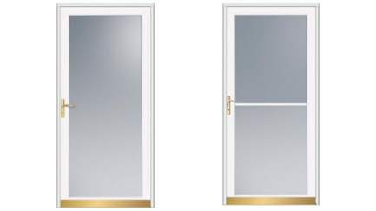

- Wood front steps may be stained without an ACR.
Section B. 23) Front Wooden Stairs and Front Railings b. The only approved stains are Olympic solid stain in color Ginger Brown and Behr solid stain in color Padre Brown.

- Wooden front steps may be replaced in kind without an ACR. Changes require an ACR.
Section B. 23) Front Wooden Stairs and Front Railings d. Exact replacement of stairs and rails to specification does not require an ACR. No alterations are permitted without prior written approval from the Board of Directors via an ACR. Changing from wood to composite material requires an ACR.

